Addendum to 2013 TCAP report documenting Economic impact of the project

Economic impact of public wheat and barley varieties: $12-billion/year
We completed a survey that includes information for 33 states for wheat and 10 states for barley and that cover 97% of the US wheat acreage (Appendix I) and 84% of the barley acreage (Appendix II).
Production of small grains in the US in 2012 was $17.8 billion for wheat and $1.4 billion for barley (based on USDA-NASS 2012 statistics). Based on our survey, public varieties account for 68% of the wheat ($ 11.5 billion) and 34% of the barley ($413 million) total production. These numbers indicate that public breeding programs are still making a significant contribution to the production of these two crops in the US.
The barley and wheat public breeding programs are an example of collaboration between the private and public sector. Growers provide funding for the core breeding activities and USDA provides the research support through CAP, other grants, and USDA-ARS infrastructure required to keep these programs competitive.
The $12-billion production value of public wheat and barley varieties is amplified multiple times through the milling, baking, malting, and brewing industries that contribute additional jobs and value to the economy. Private companies routinely use public varieties in their crossing blocks, transferring part of this value to the private sector and further multiplying the economic benefits of the public breeding activities. We include at the end of this report a letter from the National Association of Wheat Growers documenting the value of the products of TCAP for the US growers.
An additional impact of the public varieties that is difficult to estimate economically is their emphasis on genetic disease resistance. The use of molecular markers has enabled breeders to pyramid multiple resistance genes improving resistance durability. The use of genetically resistant varieties developed by the public sector reduces the use of pesticides minimizing potential negative effects on people and the environment and saving the growers application costs.

Impact of CAP projects on production values of wheat and barley varieties
Based on our survey, we estimated that wheat and barley varieties developed with total or partial support of the CAP projects (WheatCAP, BarleyCAP and TCAP) represent roughly 20% of the wheat and 4% of the barley harvested acreage, with a production value of $3.5 billion for wheat and $62 million for barley.
To estimate how much of this value was specifically added by the CAP projects (BarleyCAP, wheatCAP and TCAP), we made the following conservative assumptions:
1) If a variety is grown commercially there must be a perceived increased value compared to other available varieties. Thus, we assumed that the currently grown varieties developed by these projects have at least a 5% advantage in production values to justify the grower’s decision to buy seed for a new variety. Therefore, we calculated first the 5% of the production value for wheat ($170.8 million) and barley ($3.1 million).
2) Varieties differ in the proportion of funds received from CAP projects and local breeding programs for their development. Some were completely developed using funds from CAP projects (e.g. MAS backcrossing programs such as Patwin 515 in CA) and others received funds from CAP projects for part of the variety development costs (e.g. selection of parental lines used in the initial crosses or selection of favorable alleles with markers). To be conservative we estimated that, on average, 10% of the variety development was contributed by the CAP projects.
We then calculated this 10% over the 5% additional production value of the CAP barley and wheat varieties (0.5% of their total value). The resulting estimate was $17.2 million per year of added value to current barley and wheat varieties by CAP projects. This is more than three times the value of current TCAP investment per year including education and overhead costs. The return value of breeding activities only materializes 5-10 years later when the resulting varieties are released, so return from the current investments are expected to extend into the future and expand as high-throughput marker technologies permeate more and more breeding activities.

Economic impact of the information and technological tools generated by CAP projects
In addition to the value captured by the public sector, part of that value of this investment is also transferred to the private sector. The maps, marker information, and marker technological developments (ISelect 9K and 92K chips, exome capture platforms, maps, etc.) are actively used by the wheat and barley private sector in the US. Many private companies use markers developed by the public sector, and even use the USDA marker labs. For example marker labs at Pioneer, Syngenta, Dow, KWS, Limagrain, and Monsanto have requested the KASP assays developed by the USDA-ARS genotyping laboratory located at Raleigh, NC. Companies actively use the MASWheat site for MAS protocols and have acknowledged the value of the site. In the east, many "private" varieties actually originate from public institutions. Purdue and Illinois release most varieties for licensing to private companies. TCAP and previous Wheat and Barley CAP project results serve the entire US wheat and barley breeding industries. In California, the public wheat breeding program has provided MAS backcrossing services and introgressed stripe rust resistance genes Yr5, Yr15, Yr17 and Yr36 and the high grain protein content gene Gpc-B1 in several private varieties that are now extensively grown in California (e.g. Blanca Grande 515, Summit 515, Expresso, Westmore, etc.).
We include a letter from the National Association of Wheat Growers documenting the positive perception of US wheat growers on the economic impact of the TCAP project. Testimonials from wheat growers recognizing the value of plant breeding are also documented in the TCAP film available at https://vimeo.com/72364589.
The genetic information generated from these projects provided a better understanding of the genetics of a target trait. For example, the mapping of the solid stem trait revealed a single major gene controlling solidness. The selection strategy for the leading solid stem variety in Montana (‘Vida’, 500,000 acres), was based on the genetic information obtained by the USDA-funded IFAFS program. Genetics studies have improved our understanding of the inheritance of multiple agronomic traits, which helps to design efficient breeding strategies (in addition to their direct value in MAS).
The information generated from the BarleyCAP and TCAP grants was transformative: it unlocked marker densities and breeding systems that have made genomic selection feasible. Consequently, genomic selection became a research and an educational reality. It was passed on to students and postdocs who now are using that framework as breeders in industry. These grants have also leveraged learning and education beyond the strict set of students that they funded by providing seminars, workshops and an active cohort of students interested in plant breeding.

Economic impact of the training provided by the CAP grants
We performed a survey to identify the current positions of people trained during the BarleyCAP, wheatCAP and TCAP projects (Table 1). We identified 57 individuals that currently hold positions in companies located in the US, including of the breeding and seed companies. Forty are currently working in academic institutions in the US and 18 are working in other countries (public or private). This data confirms that the CAP projects have contributed significantly to the training of the personnel currently hired by the private sector in the seed industry.
The last decade has witnessed the dismantling of many breeding programs in the public sector and their transfer to the private sector. This has resulted in limited training opportunities for students interested in plant breeding, and has resulted in a shortage of plant breeders nation-wide. The small grain breeding programs represent one of the last reservoirs of active breeding programs in the public sector that can be used to train students.
This is well documented by the huge demand of industry for the students trained by the IFAFS/CAP/TCAP projects that have been rapidly incorporated into different breeding industries in the US and abroad.
Table 1. Current positions of people trained during BarleyCAP, wheatCAP and TCAP projects.
State | Trainee | Current position
CA | Malena Faricelly | Pioneer USA
CA | Iago Hale | Professor at the University of New Hampshire
CA | Juan Carlos Brevis | Onion Breeder private sector
CA | Cristobal Uauy | Project Leader at the John Innes Centre, UK
CA | Kati Wu | Amyris Biotechnologies Associate scientist
CA | Marco Maccaferri | University of Bologna
CA | Juan Sanchez | Monsanto
CA | Eligio Bossolini | Bayer Europe
CO | Kelsey Salvo | U.S. Peace Corps, Senegal
CO | Jessi Davis | KSU graduate program
CO | Elizabeth Bloetvogel | Eurofins STA Labs, Longmont, CO
CO | Beth Econopouly | Gates Foundation, Seattle
CO | Erena Edae | USDA-ARS, Manhattan, KS
CO | Anna Pranger | Syngenta, Longmont, CO
CO | Annie Heiliger | Cargill, Fort Collins, CO
CO | Shusong Zheng | Academy of Sciences, Beijing
CO | Wahid El-Feki | University of Alexandria, Egypt
CO | Melaku Mekonnen | Syngenta, Junction City, KS
CO | Joshua Butler | Busch Agricultural Resources
CO | Sally Clayshulte | Bayer Crop Science
CO | Ben Beyer | Advanta US
CO | Jennifer Andeway | Monsanto
CO | Victoria Valdez | Colorado State Univ.
CO | Karla Rippe | Pioneer
CO | Nelson Hevner | Monsanto
IA | Shenqiang Zhong | Monsanto
IA | Elliot Heffner | Pioneer Hibred Intl.
IA | Yi Jia | Dow Agrosciences
IA | Aaron Lorenz | Assistant Professor, University of Nebraska
IA | Jesse Poland | Research Plant Geneticist, USDA-ARS, Manhattan, KS
IA | Victoria Blake | Geneticist, USDA-ARS, Albany, CA
IA | Deniz Akdemir | Postdoctoral Fellow, Cornell University, Ithaca, NY
IA | Martha Hamblin | Senior Research Associate, Cornell University, Ithaca, NY
ID | Reuben Mclean | Production manager at Pendleton Flour Mill, Blackfoot, ID
ID | Maqsood Rehman | DowAgscience, leader Soybean breeding for North America
ID | Mackenzie Ellison | DowAgscience wheat breeding Pullman, WA. Research tech
ID | Justin Wheeler | Support scientist at University of Idaho
ID | Junli Zhang | Project leader, University of California, Davis
ID | Ping Li | Assistant Professor, Huazhong Agric. Univ. Wuhan, China
KS | Xiaofei Wang | Bioinformatician University of Kansas
KS | Shubing Liu | Research Scientist in KSU
KS | Amy Bernardo | Research Scientist in KSU
KS | Irazema Fuentes-Bueno | USDA-ARS, Manhattan, KS as technician
KY | Lloyd May | Monsanto
KY | Beiyan Zeng | Monsanto
KY | Virginia Verges | Don Mario Seeds
KY | Andres Agostinelli | Limagrain
KY | Ana Balut | Monsanto Argentina
KY | Carrie Knott | UK faculty
KY | Herry Utomo | LSU
MN | Xiuling Zhang | Corn Breeder, Pioneer Hi-Bred, Mankato MN
MN | Alex Rigor | Rice Breeder, Pioneer Hi-Bred, Philippines
MN | Toi Tsilo | Wheat Geneticist, Agricultural Research Council, South Africa
MN | Ed Quirin | Marker Analytics, Pioneer Hi-Bred, Johnston IA
MN | Godwin Macharia | Kenya Agricultural Research Institute, Kenya
MN | Brian Seda | Soybean Breeder, Pioneer Hi-Bred, York NE
MN | Trevor Keith | Research Associate, Pioneer Hi-Bred
MN | Jon Massman | Pioneer
MN | Carol Powers | Dow
MN | Vikas Vikram | Monsanto
MN | Warren Kruger | Monsanto
MN | Hongyun Wang | Pioneer Hi-Bred
MN | Michael Van de Weghe | Pioneer Hi-Bred Intern
MT | Hussein Abdul-Haleem | University of Georgia
MT | Jeremy Jewell | Washington State University
MT | Deven See | Washington State University
MT | Steve Larson | USDA-Logan, Utah
MT | Don Lee | Univ. Nebraska, Lincoln
MT | Jeong Shin | Seoul University
MT | Jason Cook | Monsanto
MT | Yukiko Naruoka | Washington State University
MT | Gail Sharp | Monsanto
MT | John Erpelding | USDA Scientist
MT | Megan Hartzell | Forage Genetics
MT | Peng Wah Chee | University of Georgia
MT | Xueyan Shan | Misissippi State University
MT | Eric Storlie | Colorado State University
NY | Chiranth C. Rajashekar | Sathguru, India
NY | Keith Williams | Agreliant
NY | Emily Combs | DuPont Pioneer
ND | Ana Correa-Heileman | Monsanto
ND | Magan Lewis | Dow AgroSciences
ND | Fabio Pedraza | Seeds 2000
NE | Nicholas Crowley | Corn Breeder, Pioneer
NE | Neway Mengistu | Corn Breeder, Pioneer
NE | Kayse Onweller | Assistant Wheat Breeder, Bayer Crop Science
NE | Ali Bakhsh | Professor, College of Agriculture Dera Ghazi Khan
NE | Anyamanee Auvachanon | Professor, Kasetsart University at KPS, Thailand
NE | Ibrahim Salah El-Baysoni | Postdoctoral Scientist, University of Nebraska
NC | Jared Benson | Molecular Breeding Scientist, Pioneer Hi-Bred
NC | Leandro Perugini | Research Scientist, Pioneer Hi-Bred
NC | Tristan Coram | ‎Agronomic & Phenotyping Group Leader at Dow AgroSciences
NC | Raja Kota | Senior Scientist, Syngenta
NC | Eric Olson | Assistant Professor, Wheat Breeding Michigan State University
NC | Marla Hall | Wheat Breeder, Limagrain Cereal Seeds
OK | Chor_Tee Tan | Texas A&M University - Texas AgriLife
OK | Tilin Fang | Oklahoma State University
OK | Tianrong Huang | Inst. Grain Crops, Xinjiang Acad. Agric. Sci., P.R. China
OK | Xinkai Zhu | Yangzhou University, P.R. China
OR | Juan Rey | Dow Agrosciences
OR | Scott Fisk | Oregon State University
OR | Alfonso Cuesta-Marcos | Oregon State University
OR | Natalie Graham | Cos County, Oregon
OR | Yada Chutimanitsakun | Kasetsart University
OR | Kelley Richardson | USDA/ARS
VA | Greg Berger | Hybrid Rice Breeder, U. of Arkansas, Rice RE Center, Stuttgart, AR
VA | Mark Christopher | Assistant Wheat Breeder, KWS-U.S., Wooster, OH
VA | Pat O’Boyle | Sugar Beet Breeder, Betaseed, Inc., Shakopee, MN.
VA | Sam Markell | Assistant Professor, North Dakota State University, Fargo, ND
VA | Jianli Chen | Assistant Professor, University of Idaho, Aberdeen, ID
VA | Jafar Mammadov | DOW Agro Sciences, Indianapolis, IN
VA | Robert Paris | Research Geneticist, American Chestnut Foundation, VA
VA | Sixin Liu | Molecular Biologist, USDA-ARS, Kearneysville, WV
VA | Young-Soo Chung | Professor, Korea University, Seoul, South Korea
WA | Carter, Arron | Washington State University

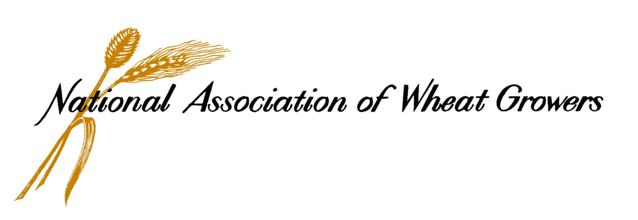
415 Second St. NE, Suite 300 ● Washington, DC 20002 ● (202) 547-7800 ● www.wheatworld.org
Dr. Jorge Dubcovsky
University of California-Davis
Dept. of Plant Sciences, One Shields Ave.
University of California, Davis, CA 95616

Dr. Gary Muehlbauer
University of Minnesota
411 Borlaug Hall, 1991 Upper Buford Circle
University of Minnesota, Department of Agronomy and Plant Genetics
St. Paul, MN 55108-6026

Lead PI’s, USDA-NIFA TCAP Grant

Dear Drs. Dubcovsky and Muehlbauer:

The National Association of Wheat Growers (NAWG), its member states and state wheat organizations across the country have long supported your USDA-National Institute of Food and Agriculture (NIFA) TriticeaeCAP (TCAP) grant work to improve barley and wheat germplasm for changing environments. We appreciate your report on the third year of this work and, based on your progress and continued work, we are pleased to reiterate our support for your vital work

We are impressed by the progress achieved in such a short period of time. In particular we would like to recognize the TCAP project for the release of more than 90 new varieties and germplasm, which are essential to maintain the competitiveness of the wheat crop and wheat growers. Improved varieties from TCAP and previous USDA-funded CAP projects are having a positive economic impact on our industry. It has long been recognized that the release of a new cultivar represents a significant return on investment. For example, an economic analysis of Kansas wheat breeding by Barkley (1997) estimated a return of 39% on investment of public dollars (KAES Progress Report 793). Thus, it is clear that the economic impact of the new variety releases is significant.

Importantly, your work within the TCAP project has led to the identification of new resistance genes against leaf rust, stem rust and stripe rust and their deployment in new varieties. This is an accomplishment that has enormous agronomic, environmental and economic benefits, reducing the need for expensive fungicides and increasing the productivity and profitability of our wheat growers.

We also recognize the long-term impact of the TCAP project’s emphasis on the training of new wheat breeders. Wheat growers are focused on improving their production practices in the short term, and they understand that wheat research is a long-term proposition necessitating infrastructure in the form of human and monetary resources. Your ability to work closely with the next generation of breeders may be your most significant contribution to the overall economic health and longevity of the wheat industry.

In summary, we continue to be grateful for the TCAP project’s focus on long-term environmental concerns such as climate change and nitrogen use efficiency as well as the significant economic impact that this project is already having on the wheat industry. We look forward to continued work together with you and your colleagues.

Sincerely,

Bing Von Bergen
President
National Association of Wheat Growers

Appendix I. Acreage and production from wheat public varieties (and from varieties generated by MAS)
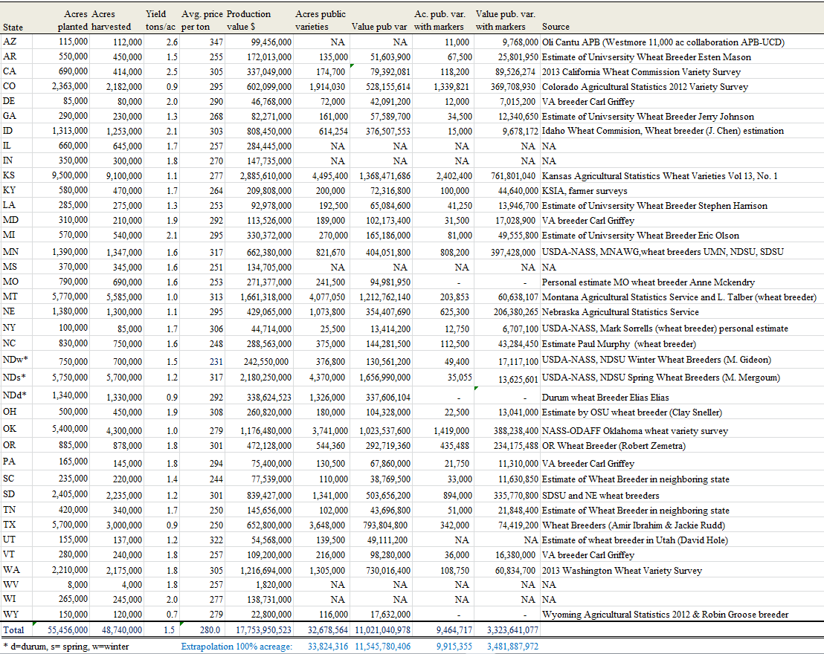

Appendix II. Acreage and production from barley public varieties (and from varieties generated by MAS)

